Unit 4 Evaluation & Assessment Review

Be able to label & 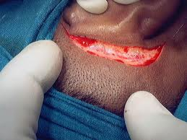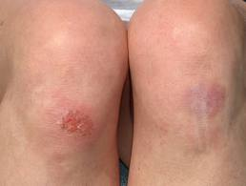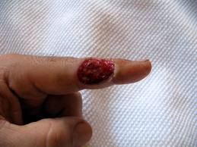define the following:

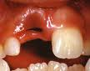

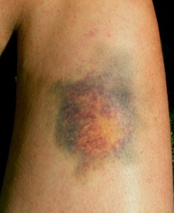

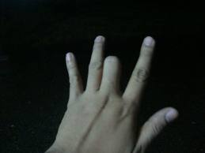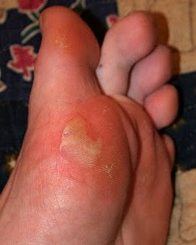

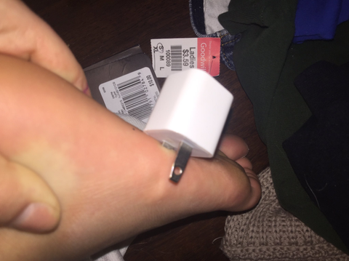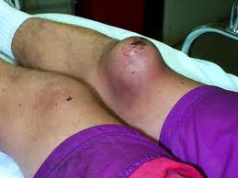

Four Positive Effects of Exercise Four Negative Effects of Exercise  
________________________________________________________________________________________________________________________________________________________________________________________________________________________________________________________________________  
________________________________________________________________________________________________________________________________________________________________________________________________________________________________________________________________________

Be able to identify the three types of mechanical force injuries & what they may cause:  
________________________________________________________________________________________________________________________________________________________________________________________________________________________________________________________________________  
____________________________________________________________________________________________________________________________________

Define the following: NOTE & UNDERSTAND THE DIFFERENCES!

Muscle Cramp: _________________________________________________________________________________________________________

___________________________________________________________________________________________________________________________

Muscle Spasm: _________________________________________________________________________________________________________

___________________________________________________________________________________________________________________________

Acute Onset Muscle Soreness: ________________________________________________________________________________________

___________________________________________________________________________________________________________________________

Delayed Onset Muscle Soreness: ______________________________________________________________________________________

___________________________________________________________________________________________________________________________

Tendinitis: ______________________________________________________________________________________________________________

___________________________________________________________________________________________________________________________

Strain: ___________________________________________________________________________________________________________________

Be able to define & identify:

Avulsion Fracture: ___________________________________________________________________________

___________________________________________________________________________________________

Blowout Fracture: ___________________________________________________________________________ ___________________________________________________________________________________________

Comminuted Fracture: _______________________________________________________________________ ___________________________________________________________________________________________

Contrecoup Fracture: ________________________________________________________________________

___________________________________________________________________________________________

Depression Fracture: _________________________________________________________________________

___________________________________________________________________________________________

Epiphyseal Fracture: _________________________________________________________________________

___________________________________________________________________________________________

Impacted Fracture: __________________________________________________________________________

___________________________________________________________________________________________

Longitudinal Fracture: ________________________________________________________________________

___________________________________________________________________________________________

Oblique Fracture: ____________________________________________________________________________

___________________________________________________________________________________________

Serrated Fracture: ___________________________________________________________________________

___________________________________________________________________________________________

Spiral Fracture: ______________________________________________________________________________

___________________________________________________________________________________________

Stress Fracture: _____________________________________________________________________________

___________________________________________________________________________________________

Transverse Fracture: _________________________________________________________________________

___________________________________________________________________________________________

Greenstick Fracture: _________________________________________________________________________

___________________________________________________________________________________________

What is a sprain? _______________________________________________________________________________________________________________

What is a: First degree sprain: _________________________________________________________________________________________________

___________________________________________________________________________________________________________________________

Second degree sprain: _________________________________________________________________________________________________

___________________________________________________________________________________________________________________________

Third degree sprain: ___________________________________________________________________________________________________

___________________________________________________________________________________________________________________________

Explain the difference between a dislocation & a subluxation.

____________________________________________________________________________________________________________________________________________________________________________________________________________________________________________________________________________________________________________________________________________________________________________________________________________

What is a bursa & why is it important?

____________________________________________________________________________________________________________________________________________________________________________________________________

Explain the difference between hypoesthesia & hyperesthesia. What are the possible consequences of each?

____________________________________________________________________________________________________________________________________________________________________________________________________________________________________________________________________________________________________________________________________________________________________________________________________________

**CUMULATIVE REVIEW**

Unit One:

What are the anatomical directions? What do they mean? __________________________________________________________________

________________________________________________________________________________________________________________________________________________________________________________________________________________________________________________________________________

Define anatomical position & understand why it is important. _____________________________________________________________

____________________________________________________________________________________________________________________________________

Define the following anatomical terms:

Flexion: _________________________________________________________________________________________________________________

___________________________________________________________________________________________________________________________

Extension: ______________________________________________________________________________________________________________

___________________________________________________________________________________________________________________________

Abduction: ______________________________________________________________________________________________________________

___________________________________________________________________________________________________________________________

Adduction: ______________________________________________________________________________________________________________

___________________________________________________________________________________________________________________________

Inversion: _______________________________________________________________________________________________________________

___________________________________________________________________________________________________________________________

Eversion: ________________________________________________________________________________________________________________

___________________________________________________________________________________________________________________________

Internal rotation: _______________________________________________________________________________________________________

___________________________________________________________________________________________________________________________

External rotation: ______________________________________________________________________________________________________

___________________________________________________________________________________________________________________________

Unit Two: REFAMILIARIZE YOURSELF WITH THE NAMES OF THE BONES! This is something you should do consistently without a test coming up. If you hope to be successful in the coming semester, anatomy needs to become second nature! 😊

Unit Three: We went over soft tissue injuries during Lesson Seven! These notes will come in handy for the first page of your study guide!